**Question)**

172.19.67.0 /24

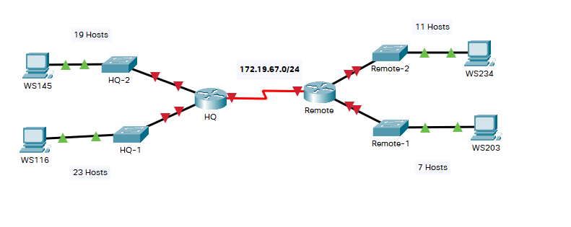

**Answer)**

|  |  |  |  |
| --- | --- | --- | --- |
|  | Name | Needed IP’s | Min Available IP |
| 1 | HQ-1 | 19+2 = 21 | 32 |
| 2 | HQ-2 | 23+2 = 25 | 32 |
| 3 | Remote-1 | 7+2 = 9 | 16 |
| 4 | Remote-2 | 11+2 = 13 | 16 |
| 5 | Routers | 2+2 = 4 | 4 |

|  |  |  |  |  |  |
| --- | --- | --- | --- | --- | --- |
|  | Subnet Address | Startin IP | End IP | Broadcast Address | Subnet Mask |
| 1 | 172.19.67.0 | 172.19.67.1 | 172.19.67.31 | 172.19.67.32 | 255.255.255.224 |
| 2 | 172.19.67.32 | 172.19.67.33 | 172.19.67.62 | 172.19.67.63 | 255.255.255.224 |
| 3 | 172.19.67.64 | 172.19.67.65 | 172.19.67.78 | 172.19.67.79 | 255.255.255.240 |
| 4 | 172.19.67.80 | 172.19.67.81 | 172.19.67.94 | 172.19.67.95 | 255.255.255.240 |
| 5 | 172.19.67.96 | 172.19.67.97 | 172.19.67.98 | 172.19.67.99 | 255.255.255.252 |